Course in Forensic Odontology
Disaster Victim Identification
Organised by
Department of Forensic Medicine
Aarhus University
with the patronage of IOFOS

October 17th to October 21st, 2016

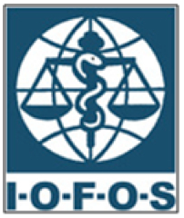

To pre-register please fill out this form and mail it to dbindslev@forens.au.dk before September 16th, 2016

Name:

Position, title:

E-mail:

Full address:

Phone, office:

Mobile phone:

Please note: The number of participants is limited. When you have been pre-accepted you will receive notification and billing information. Your participation is formal when the fee has been paid.

